LAB1 Report

111550016 于子博

My results for d = [50:50:600]

Run LAB1_111550016.m, and the results will be displayed in the command window. However, note that the results will output d=50~600 (every 50) first, and then output the results of Constellation Diagrams for 600, 400, 200, and 100.

For d = [50:50:600], just look at the first part of output(d=50~600 (every 50)).

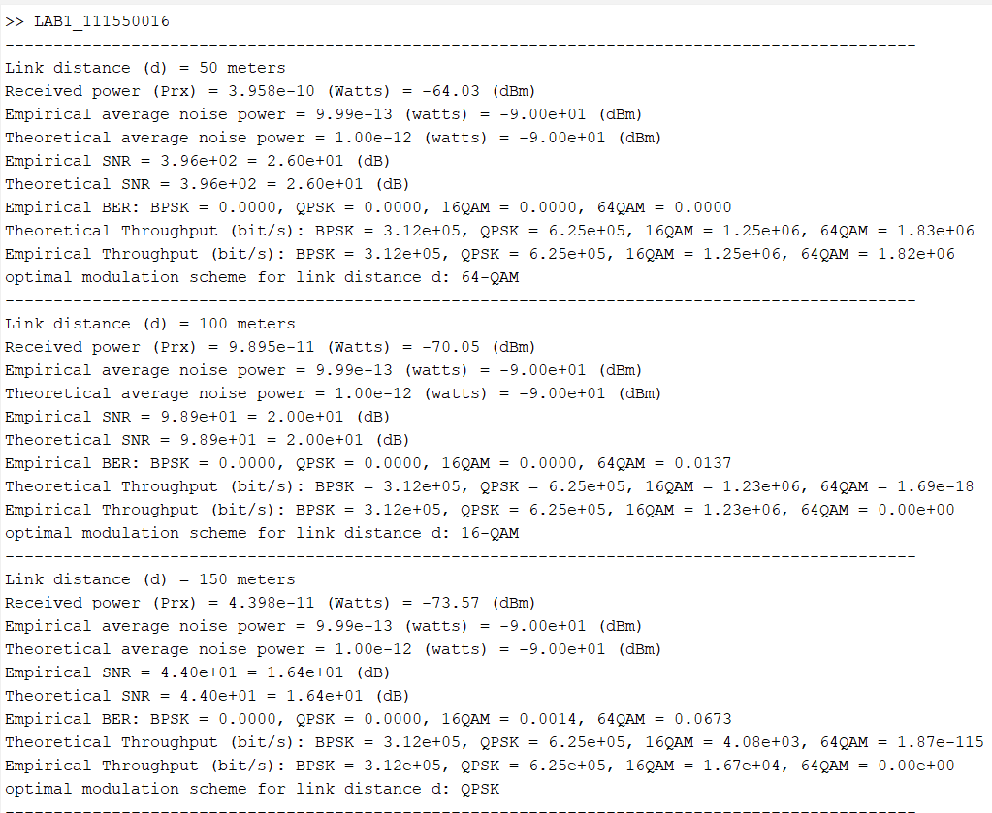

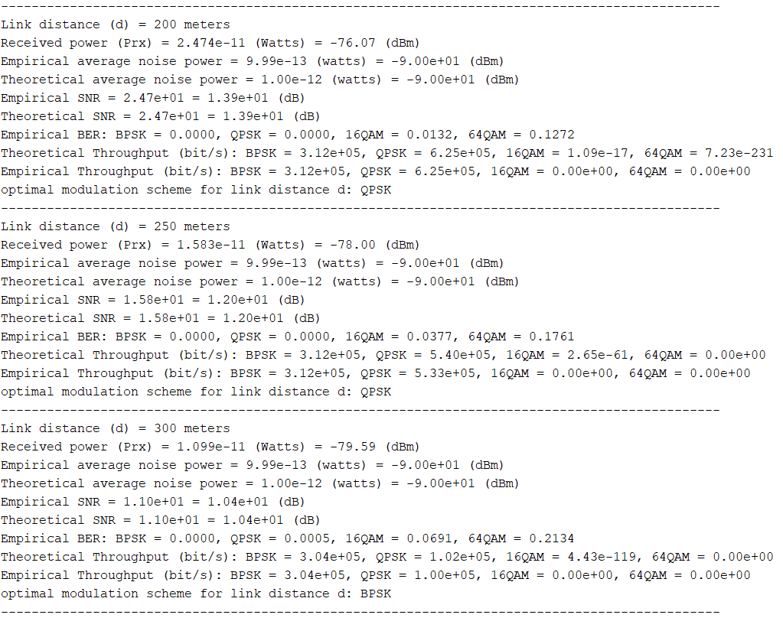

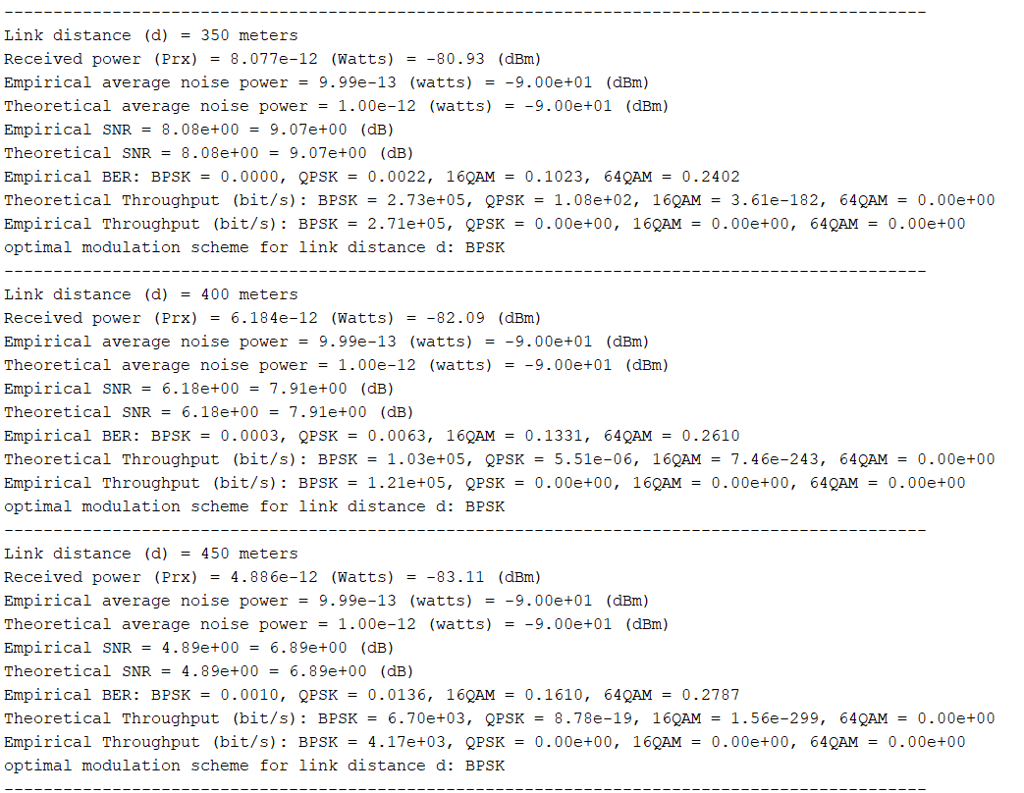

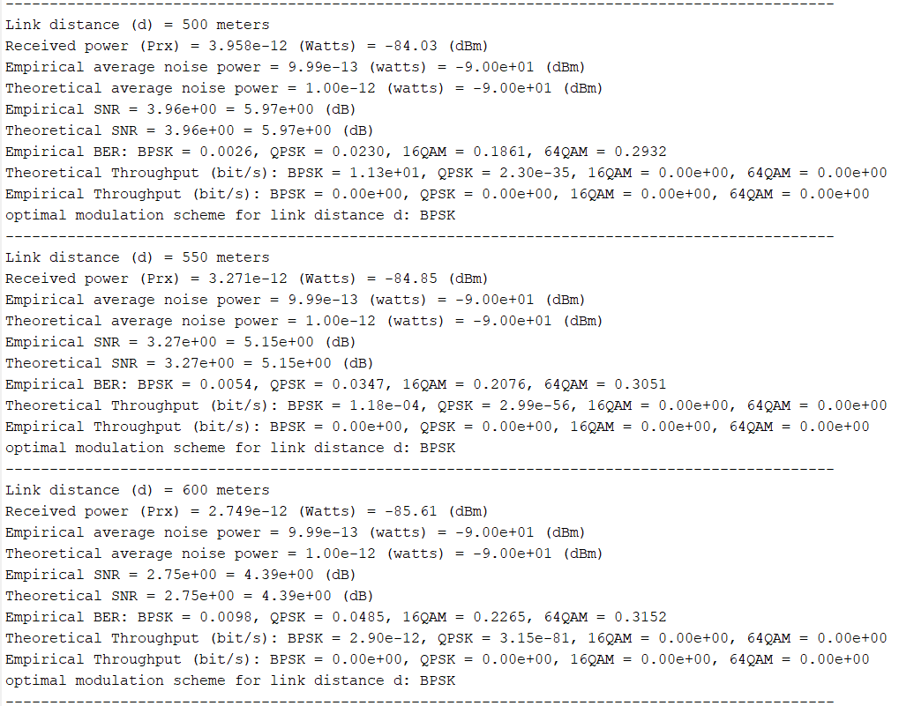

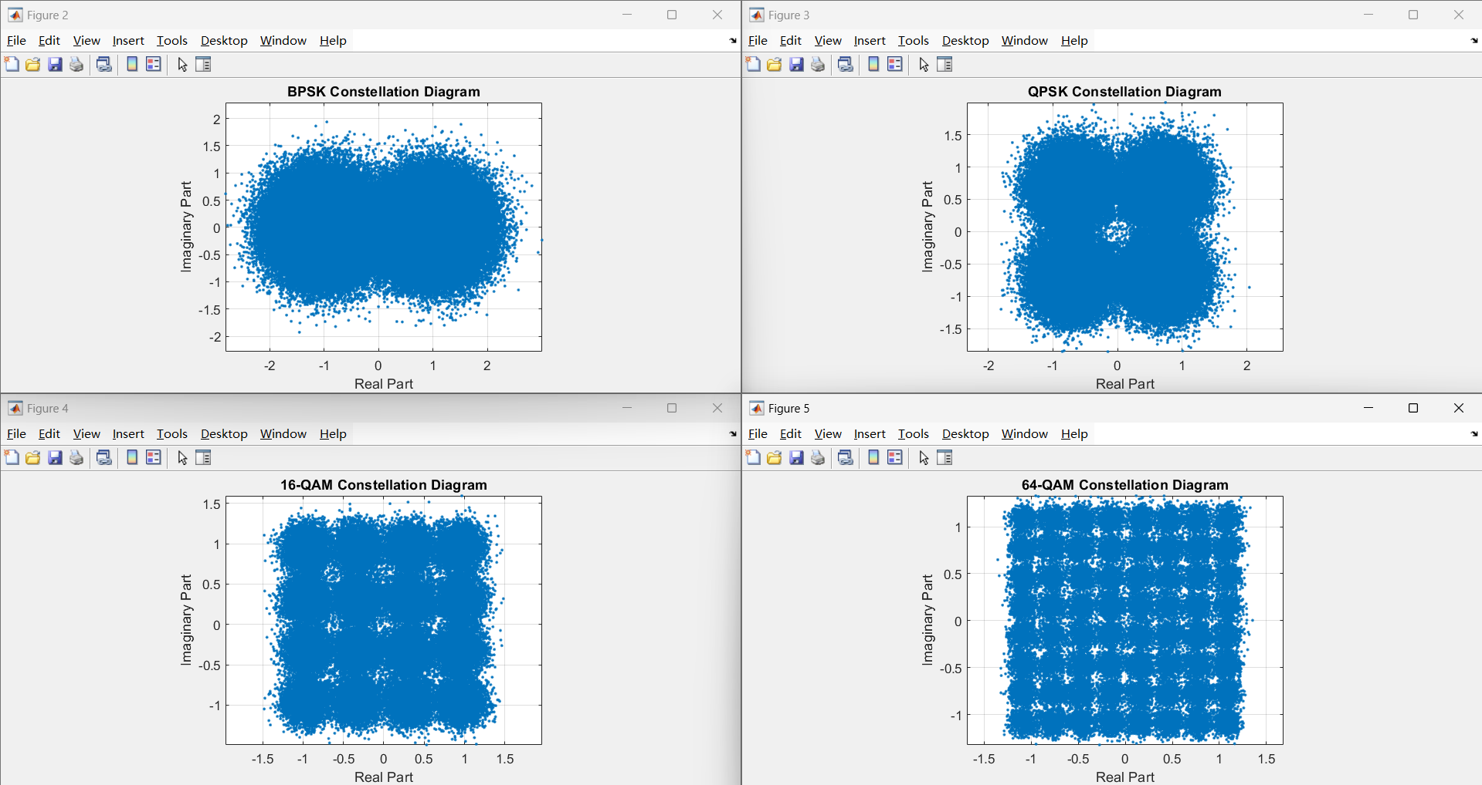

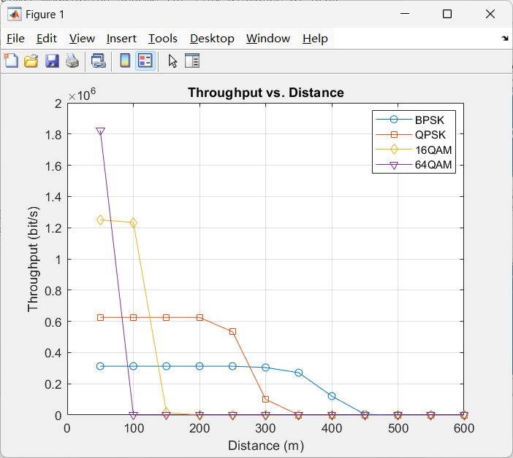

Assume there exists a theoretical modulation table given in SNR_BER.mat

Run report_question_111550016.m, and modify the 'packet_len_bit' in line 276 to 100, 2000, 4000 to test all results.

Packet size = 100 bits

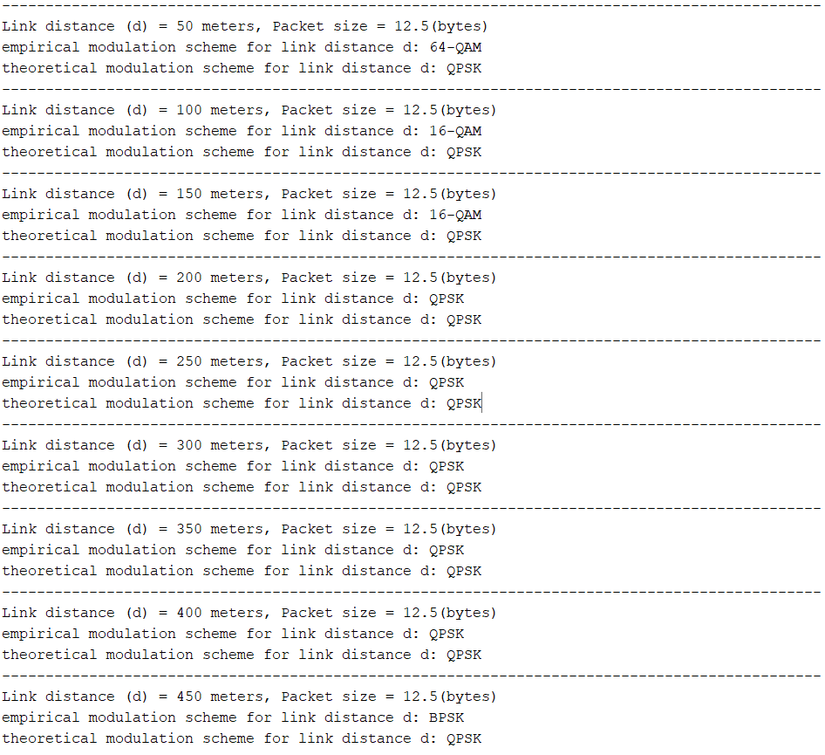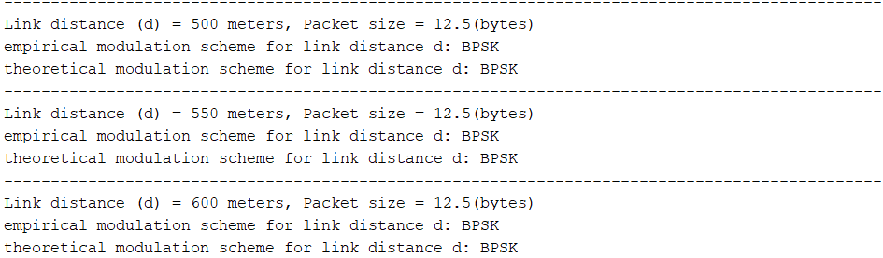

Packet size = 2000 bits

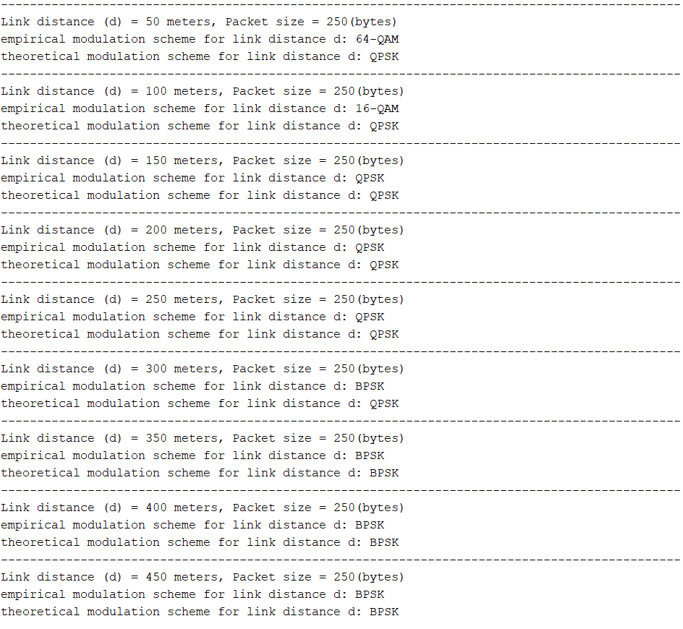

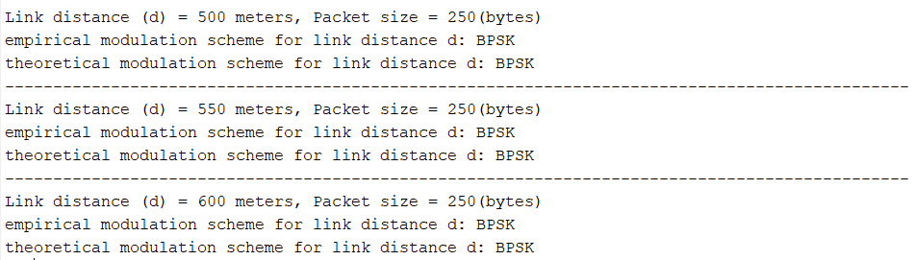

Packet size = 4000 bits

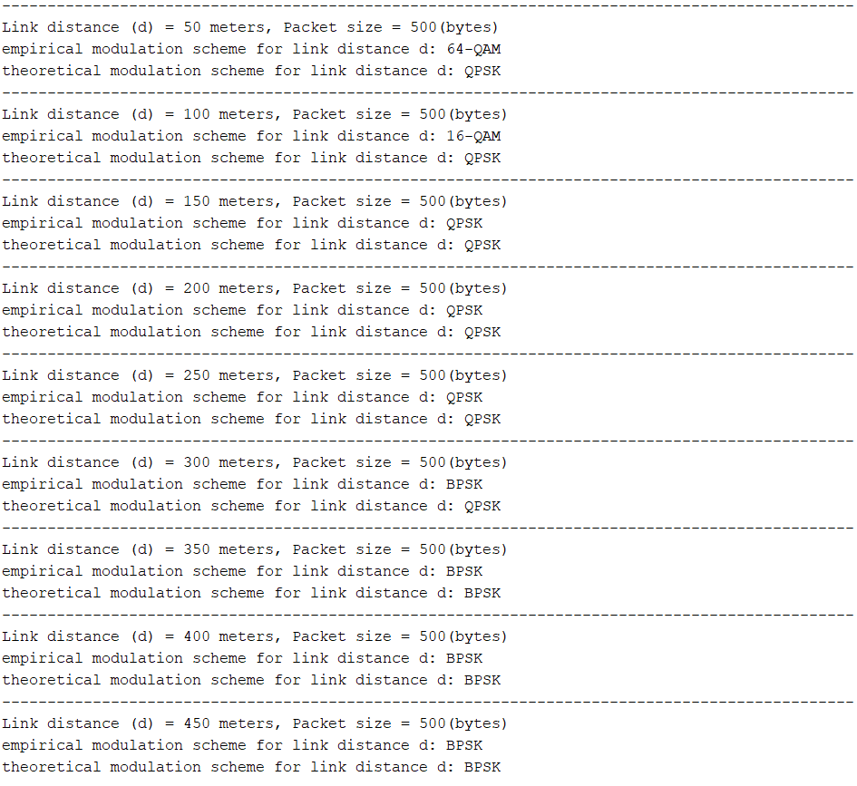

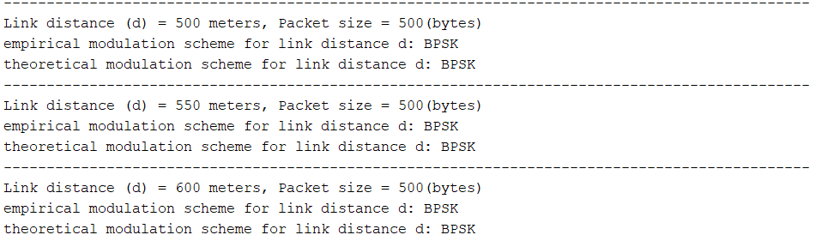

Note: The empirical modulation scheme involves inputting d and l into previously computed LAB data, the theoretical modulation scheme calculates using data from SNR_BER.mat.

Compare: For the theoretical modulation scheme, QPSK is used when the distance is smaller, and BPSK is used when it is larger, although 16-QAM and 64-QAM were not utilized in the testing. The theoretical modulation scheme closely aligns with the empirical modulation scheme when the distance is larger.

What have you learned from this lab?

Ans: I have learned a lot from this LAB session and clarified many concepts that I previously didn't understand, such as the usage of dBm, watts, and dB, and also learned many MATLAB techniques.

What difficulty have you met in this lab?

Ans: Basically, each task is a big problem. Not only does it require good mathematical skills, but also a complete understanding of communication principles. Moreover, there are many small details that need attention, making it really challenging.